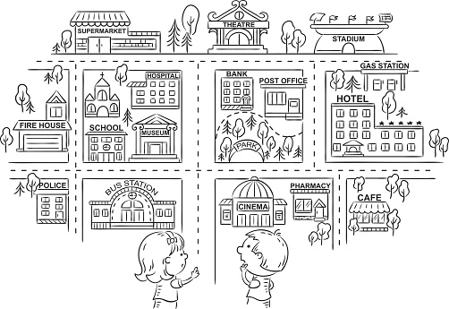

- Dopolni z ustreznim predlogom: IN FRONT OF, OPPOSITE, BEHIND, NEXT TO, BETWEEN
The bus station is ____________________ the police station and the cinema.
The school is ________________________ the museum.
The gas station is ____________________ the hotel.
The theatre is _______________________ the supermarket and the stadium.
The park is __________________________ the bank.
The hospital is _______________________ the museum.
The supermarket is ___________________ the theatre.
The stadium is _______________________ the gas station.
The church is ________________________ the school.
The post office is _____________________ the bank.
The café is __________________________ the hotel.
The pharmacy is _____________________ the cinema and the café.
The school is ________________________ the church.
The post office is _____________________ the park.
The museum is ______________________ the hospital.

- Napiši, kaj fant in punca rada delata in kdaj.

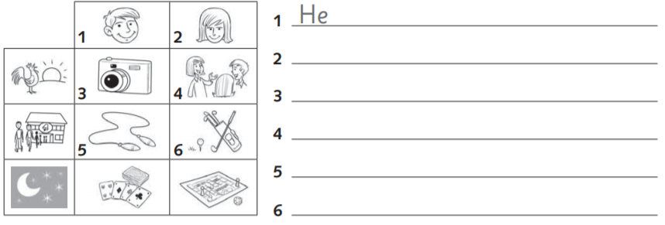
- Poimenuj poklice.
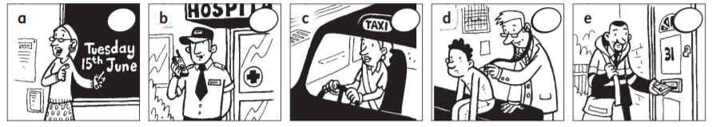
- ________________________ b) _______________________ c) ___________________________
- _________________________ e) ____________________

d)Opiši kaj otroci delajo in kdaj.
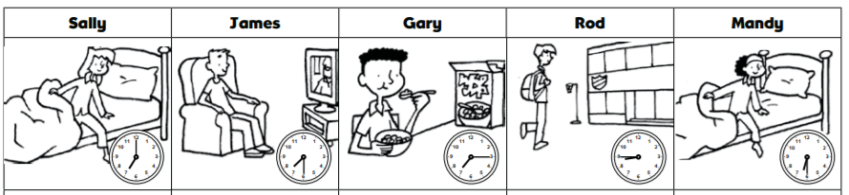
1. Sally __________________________________.
2. James __________________________________.
3. Gary _____________________________________.
4. Rod ________________________________.
5. Mandy _____________________________:

REŠITVE
a)
The bus station is between the police station and the cinema.
The school is next to the museum.
The gas station is behind the hotel.
The theatre is between the supermarket and the stadium.
The park is in front of the bank.
The hospital is behind the museum.
The supermarket is next to the theatre.
The stadium is opposite the gas station.
The church is behind the school.
The post office is next to the bank.
The café is opposite the hotel.
The pharmacy is between the cinema and the café.
The school is in front of the church.
The post office is behind the park.
The museum is in front of the hospital.

b)
1. He likes taking photos in the morning.
2. She likes talking to friends in the morning.
3. He likes skipping after school.
4. She likes playing golf after school.
5. He likes playing cards at night.
6. She likes playing board games at night.

c)
A TEACHER A SECURITY GUARDS A TAXI DRIVER A DOCTOR A POSTMAN
d)
1. Sally gets up at seven o'clock.
2. James watches tv at half past seven.
3. Gary has breakfast at quarter past seven.
4. Rod goes to school at quarter to eight.
5. Mandy gets up at half past six.

