UČNI LIST: Utrjujemo in ponavljamo

- IN TOWN
- WHERE IS…? Dopolni z IN FRONT OF, NEXT TO, BEHIND, IN, OPPOSITE, BETWEEN
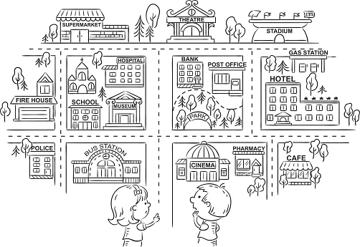
Pomoč:
*gas station (bencinska p.)
*stadium (športni stadion)
*theatre (gledališče)
*post office (pošta)
*fire house (gasilni dom)
*pharmacy (lekarna)

- There are a lot of buildings _______________ this town.
- The bus station is ____________________ the police station and the cinema.
- The school is ________________________ the museum.
- The gas station is ____________________ the hotel.
- The park is __________________________ the bank.
- A café is _________________________ the pharmacy.
- A supermarket is ___________________ the theatre.
- The stadium is _______________________ the gas station.

- ANSWER. Odgovori.
- Is there a church? Yes,__________________
- Is there a ZOO? No,_____________________
- Is there a restaurant? _____________________
- Is there a hospital? _______________________
- Are there any children? ___________________
- Are there any cars?_______________________
- Where can you watch a new film? At ___________________
- Where can you watch football?_________________________
- Where can you have a picnic? _________________________
- You can drink a cup of tea or coffee ______________________

2. ACTIVITIES
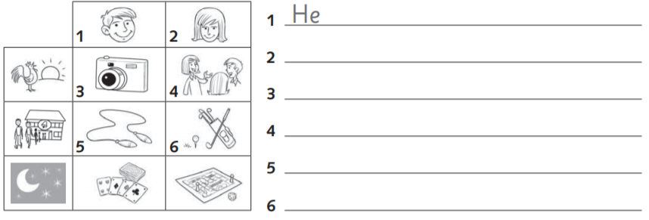
- Napiši, kaj fant in punca rada delata in kdaj.
- Odgovori na vprašanja: nato zapiši povedi v angleščini.
Do you like playing cards? ____________________________
Does your sister like doing exercises? _______________________
Does your dad like talking to friends? _________________________
Rad se igram z balinčki. ________________________________________________
Moja mami se rada igra namizne igre. ______________________________________
Ne maram si podajati frizbija. _____________________________________________
Moja babica ne mara plavati. ______________________________________________

- Dopolni povedi z ENO manjkajočo besedo.
- It's very __________ in winter. There is a lot of __________ in the mountains.
- __________ is a winter sport. You need skis, poles and a __________.
- Lucy likes sledging. She’s going very __________
- Tennis is interesting, too. There are two __________.
They __________ a small ball over the net.
- Teacher’s got a camera. She is taking some __________ flowers and trees.
- Portorož is a beautiful __________. There are a lot of __________.

REŠITVE
1.1
- There are a lot of buildings in this town.
- The bus station is between the police station and the cinema.
- The school is next to the museum.
- The gas station is behind the hotel.
- The park is in front of the bank.
- A café is opposite the pharmacy.
- A supermarket is next to the theatre.
- The stadium is opposite the gas station.
1.2
- Is there a church? Yes, there is
- Is there a ZOO? No, there isn’t.
- Is there a restaurant? No, there isn’t.
- Is there a hospital? Yes, there is.
- Are there any children? Yes, there are. (two)
- Are there any cars? No, there aren’t.
- Where can you watch a new film? At the cinema.
- Where can you watch football? At the stadium.
- Where can you have a picnic? At the park.
- You can drink a cup of tea or coffee at the café.

2.
- He likes taking photos in the morning.
- She likes talking to friends in the morning.
- He likes skipping after school.
- She likes playing golf after school.
- He likes playing cards at night.
- She likes playing board games at night.

2.2
Do you like playing cards? Yes, I do. / No, I don't.
Does your sister like doing exercises? Yes, she does. / No, she doesn't.
Does your dad like talking to friends? Yes, she does. / No, she doesn't.
Rad se igram z balinčki. I like playing skittles.
Moja mami se rada igra namizne igre. My mum likes playing board games.
Ne maram si podajati frizbija. I don't like playing Frisbee.
Moja babica ne mara plavati. My grandma doesn't like swimming.

2.3
- It's very cold in winter. There is a lot of snow in the mountains.
- Skiing is a winter sport. You need skis, poles and a helmet.
- Lucy likes sledging. She’s going very fast.
- Tennis is interesting, too. There are two players. They hit a small ball over the net.
- Teacher’s got a camera. She is taking some photos of flowers and trees.
- Portorož is a beautiful town/ city. There are a lot of flowers/ cafes/ restaurants/…

