UČNI LIST 2: utrjujemo in ponavljamo pred ocenjevanjem

1. READ AND ANSWER/ WRITE. Preberi in zapiši odgovore.
What is he wearing? What season is it? What is she wearing?

2. THERE IS, THERE ARE. Dopolni z There is ali There are.
- ____________ three apples in the fridge.
- ____________ a toy car under the bed.
- ____________ twelve students in the classroom.
- ____________ a cat under the sofa.
- ____________ boys in the street.
- ____________ a wardrobe in the corner of the bedroom.
- ____________ a lot of flowers in the garden.
- ____________ three windows in the living room.
- ____________ a lot of bananas in the basket.
- ____________ a mirror in the bathroom.
- ____________ four cars next to the house.
- ____________ one book on the shelf.
- ____________ twenty computers in the school.

3. TRUE or FALSE. Drži ali ne drži?
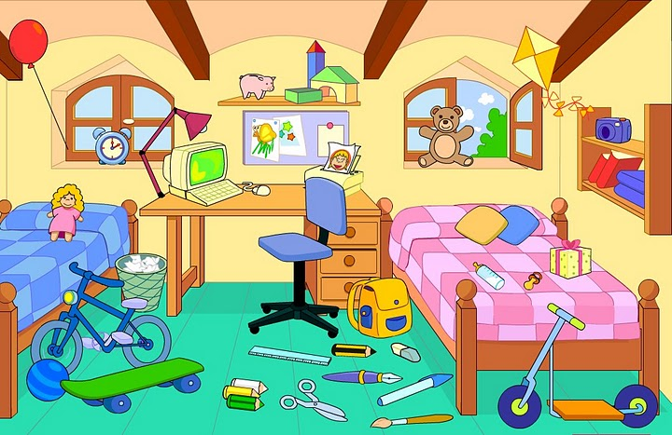
1. 1. The chair is next to the desk.
2. The beds are behind the windows.
3. The computer is under the desk.
4. There is a wardrobe.
5. The bin is between the bed and the desk.
6. The lamp is on the desk.
7. The poster is between the windows.
8. There are a lot of toys.
9. The clock is on the bed.

REŠITVE:
1.
He's wearing a red t-shirt, blue shorts and brown trainers. It's summer.
She's wearing jeans, boots, a yellow sweater (pullover, jumper), a pink coat, a blue scarf and woolly hat. It's winter / autumn.

2.
- There are three apples in the fridge.
- There is a toy car under the bed.
- There are twelve students in the classroom.
- There is a cat under the sofa.
- There are boys in the street.
- There is a wardrobe in the corner of the bedroom.
- There are a lot of flowers in the garden.
- There are three windows in the living room.
- There are a lot of bananas in the basket.
- There is a mirror in the bathroom.
- There are four cars next to the house.
- There is one book on the shelf.
- There are twenty computers in the school.

3.
1. The chair is next to the desk. TRUE
2. The beds are behind the windows. FALSE
3. The computer is under the desk. FALSE
4. There is a wardrobe. FALSE
5. The bin is between the bed and the desk. TRUE
6. The lamp is on the desk. TRUE
7. The poster is between the windows. TRUE
8. There are a lot of toys. TRUE
9. The clock is on the bed. FALSE

