a) Choose There is or There Are. Dopolni z There is ali There are.
1. ____________ three bottles of milk in the fridge.
2. ____________ a ship in the harbor.
3. ____________ twelve students in the classroom.
4. ____________ a cat under the table.
5. ____________ many boys in the street.
6. ____________ five lessons on Monday.
7. ____________ a history museum in this city.
8. ____________ a wardrobe in the corner of the room.
9. ____________ many flowers in the garden.
10. ____________ three windows in the room.
11. ____________ a stadium opposite the theatre.
12. ____________ a lot of apples in the basket.
13. ____________ three colleges in our town.
14. ____________ four cars near the house.
15. ____________ a post-office in this street.
16. ____________ many CDs on the table.
17. ____________ ten computers in this classroom.
18. ____________ a mirror in this corridor.

b) TRUE or FALSE. DRŽI ali NE DRŽI?
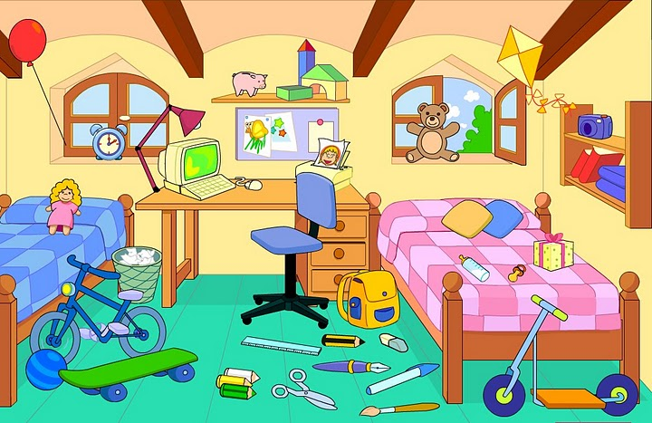
1. The chair is next to the desk
2. The beds are opposite the windows
3. The computer is under the desk
4. The bookcase is on the wall.
5. The bin is between the bed and the desk
6. The lamp is on the desk.
7. The poster is above the shelf
8. The windows are above the beds
9. The clock is on the bed.

c)
What is he wearing? What is she wearing?
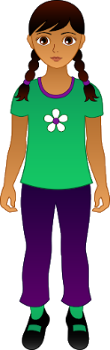

REŠITVE:
a)
1. There are three bottles of milk in the fridge.
2. There is a ship in the harbor.
3. There are twelve students in the classroom.
4. There is a cat under the table.
5. There are many boys in the street.
6. There are five lessons on Monday.
7. There is a history museum in this city.
8. There is a wardrobe in the corner of the room.
9. There are many flowers in the garden.
10. There are three windows in the room.
11. There is a stadium opposite the theatre.
12. There are a lot of apples in the basket.
13. There are three colleges in our town.
14. There are four cars near the house.
15. There is a post-office in this street.
16. There are many CDs on the table.
17. There are ten computers in this classroom.
18.There is a mirror in this corridor.

b)
1. The chair is next to the desk. TRUE
2. The beds are opposite the windows. FALSE
3. The computer is under the desk. FALSE
4. The bookcase is on the wall. FALSE
5. The bin is between the bed and the desk. TRUE
6. The lamp is on the desk. TRUE
7. The poster is above the shelf. FALSE
8. The windows are above the beds. TRUE
9. The clock is on the bed.FALSE

c)
He's wearing an orange t-shirt, blue jeans and red trainers.
She's wearing a greeen t-shirt, purple trousers, black shoes and green socks.

